**PYTHON SUMMER PROJECT**

RIYA SINGH

Student Management System

Q) Accept the student details and store in file. Display the contents when asked. Using the contents of the file you should be able to search for records of students, add marks for each student, check for the fee dues, etc…

ANS) CODE:

def a(file):

file = open("student.txt", "r")

name = input("Enter the name of the student whose records are to be found:")

name = name.lower()

name = name.capitalize()

for line in file:

for words in line.split():

if name == words:

print (line)

file.close()

def b(file):

file = open("student.txt", "a")

limit = int(input("Enter the number of records to be added:"))

for i in range(limit):

rollno = input("Enter roll number:")

name = input("Enter name:")

sub = input("Enter subject:")

marks = input("Enter marks:")

fee = input("Enter fee status:")

attendance = input("Enter attendance percentage:")

file.write(rollno)

file.write("\t")

file.write("\t")

file.write(name)

file.write("\t")

file.write("\t")

file.write(sub)

file.write("\t")

file.write("\t")

file.write(marks)

file.write("\t")

file.write("\t")

file.write(fee)

file.write("\t")

file.write("\t")

file.write(attendance + "%")

file.write("\n")

file.close()

file = open("student.txt", "r")

text = file.read()

print ("ROLL NO" + "\t" + "\t" + "NAME" + "\t" + "\t" + "SUBJECT" + "\t" + "\t" + "MARKS" + "\t" + "\t" + "FEE STATUS" + "\t"+ "\t" + "ATTENDANCE%" + "\n")

print (text)

file.close()

def c(file):

file = open("student.txt", "r")

for line in file:

for words in line.split():

if "incomplete" in words:

print (line)

file.close()

def menu():

print ("MENU:")

print ("a) looking up a student's record (nothing will show if the given student's record does not exist)")

print ("b) adding records to existing file")

print ("c) displaying record of students whose fees are incomplete (nothing will show if no student's fees are incomplete)")

file = open("student.txt", "r")

choice = input("Do you want to execute any of the above menu options? (y/n):")

while choice=="y" or choice=="Y":

menu = input("Enter option to be executed:")

if menu=="a" or menu=="A":

a(file)

elif menu=="b" or menu=="B":

b(file)

elif menu=="c" or menu=="C":

c(file)

else:

print ("Invalid input")

choice=input("Do you want to continue? (y/n):")

file.close()

def show(file):

file = open("student.txt", "r")

choice = input("Do you want to see the records? (y/n):")

print ("ROLL NO" + "\t" + "\t" + "NAME" + "\t" + "\t" + "SUBJECT" + "\t" + "\t"+ "MARKS" + "\t" + "\t" + "FEE STATUS" + "\t" + "\t" + "ATTENDANCE%" + "\n")

if choice=="y" or choice=="Y":

text = file.read()

print (text)

choice = 'n'

file.close()

menu()

def writing():

file = open("student.txt", "w")

limit = int(input("Enter a limit:"))

for i in range(limit):

rollno = input("Enter roll number:")

name = input("Enter name:")

sub = input("Enter subject:")

marks = input("Enter marks:")

fee = input("Enter fee status:")

attendance = input("Enter attendance percentage:")

file.write(rollno)

file.write("\t")

file.write("\t")

file.write(name)

file.write("\t")

file.write("\t")

file.write(sub)

file.write("\t")

file.write("\t")

file.write(marks)

file.write("\t")

file.write("\t")

file.write(fee)

file.write("\t")

file.write("\t")

file.write(attendance + "%")

file.write("\n")

file.close()

show(file)

writing()

OUTPUT:

* Step-by-Step output:

#initially when no information is entered, i.e. when the program has just started.

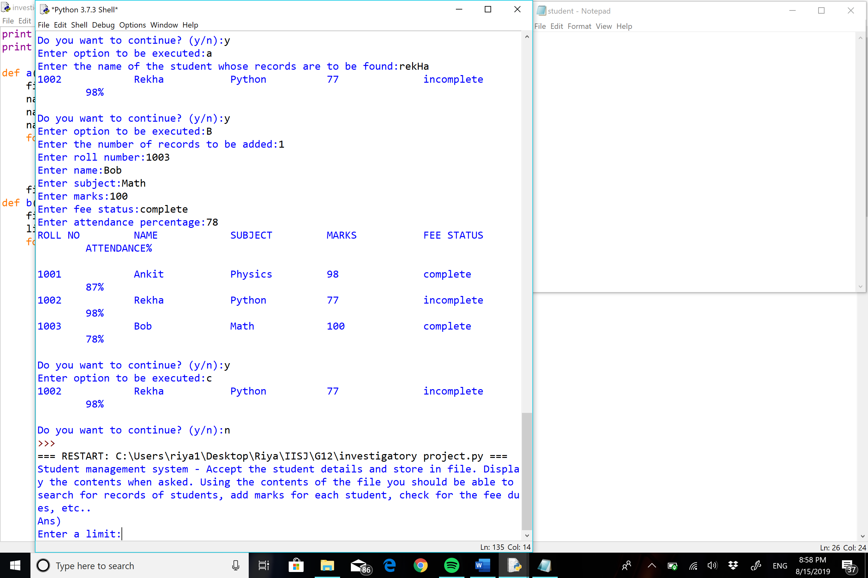 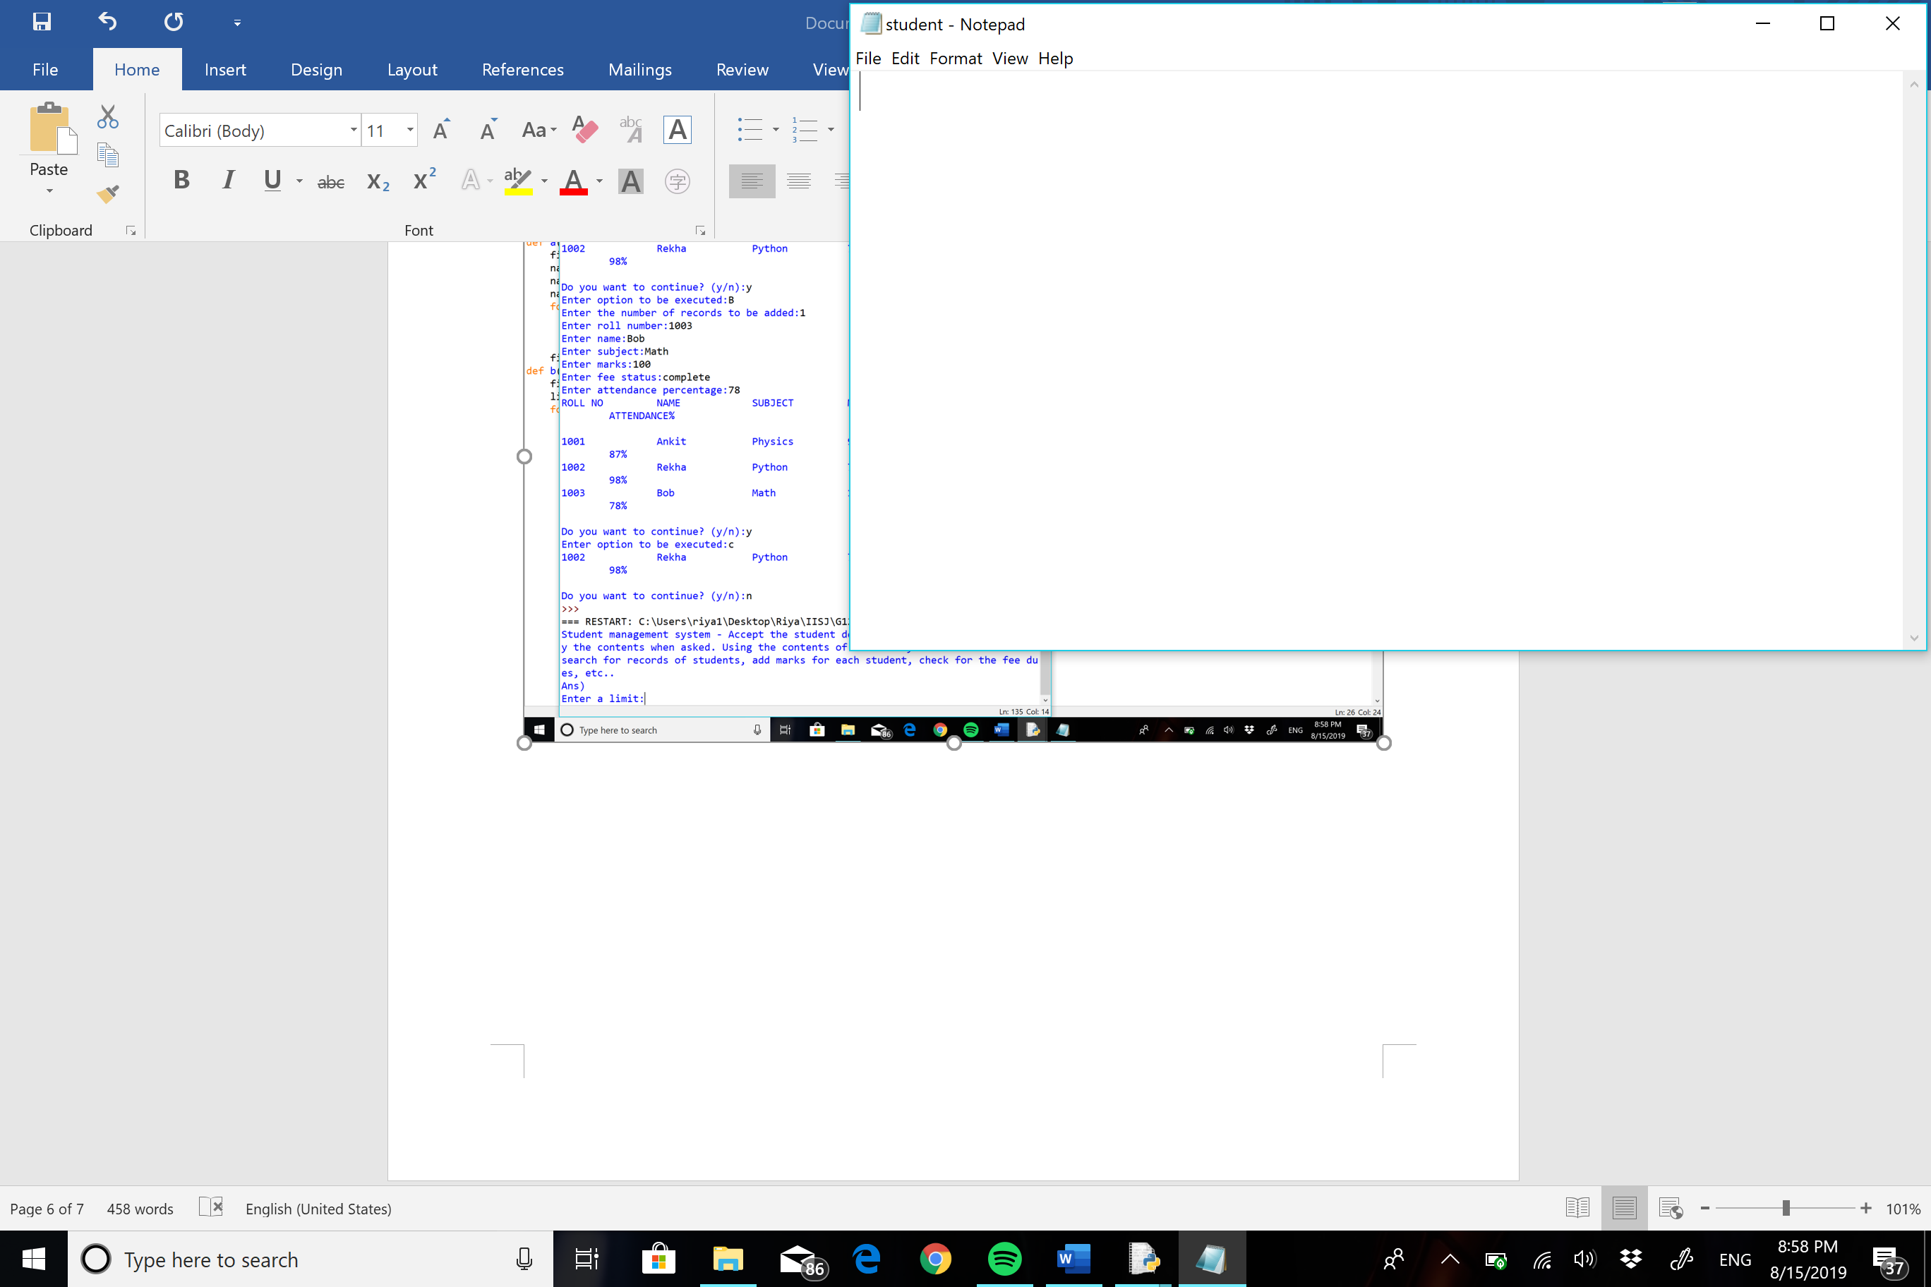

#when information is entered.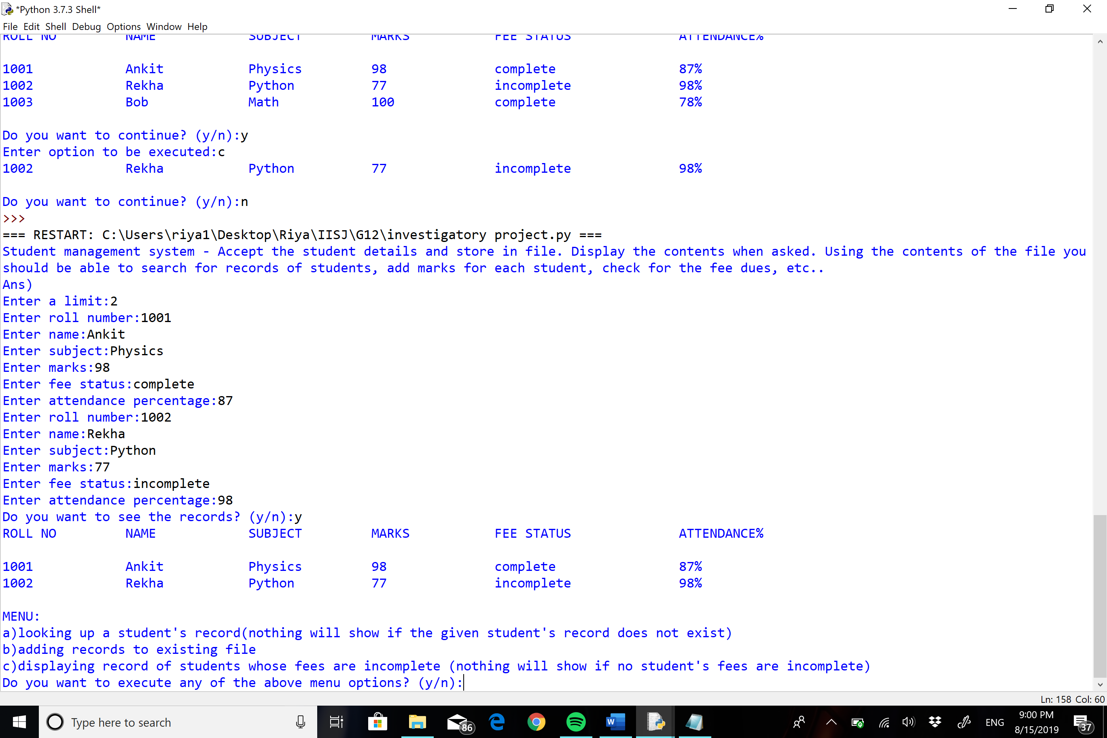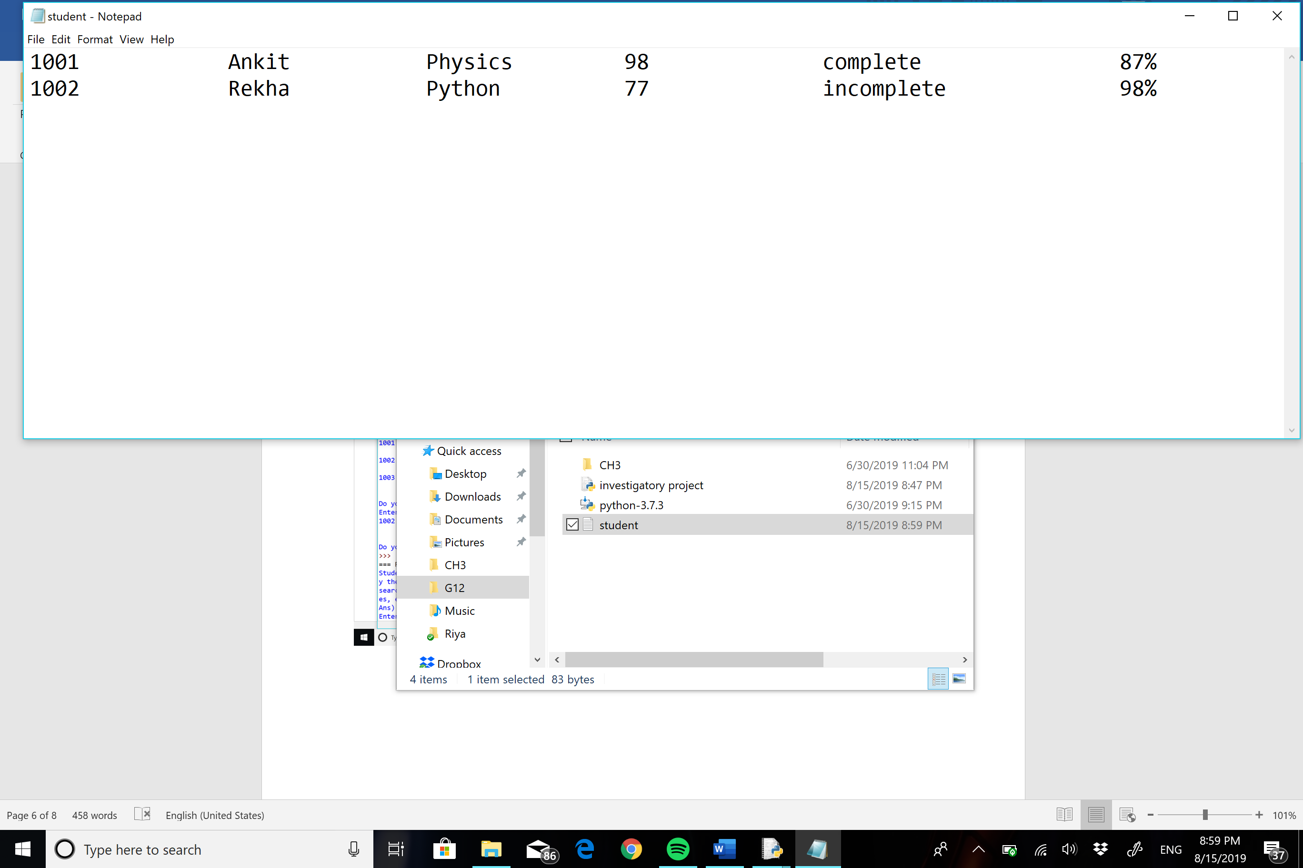

#when information is added to existing file.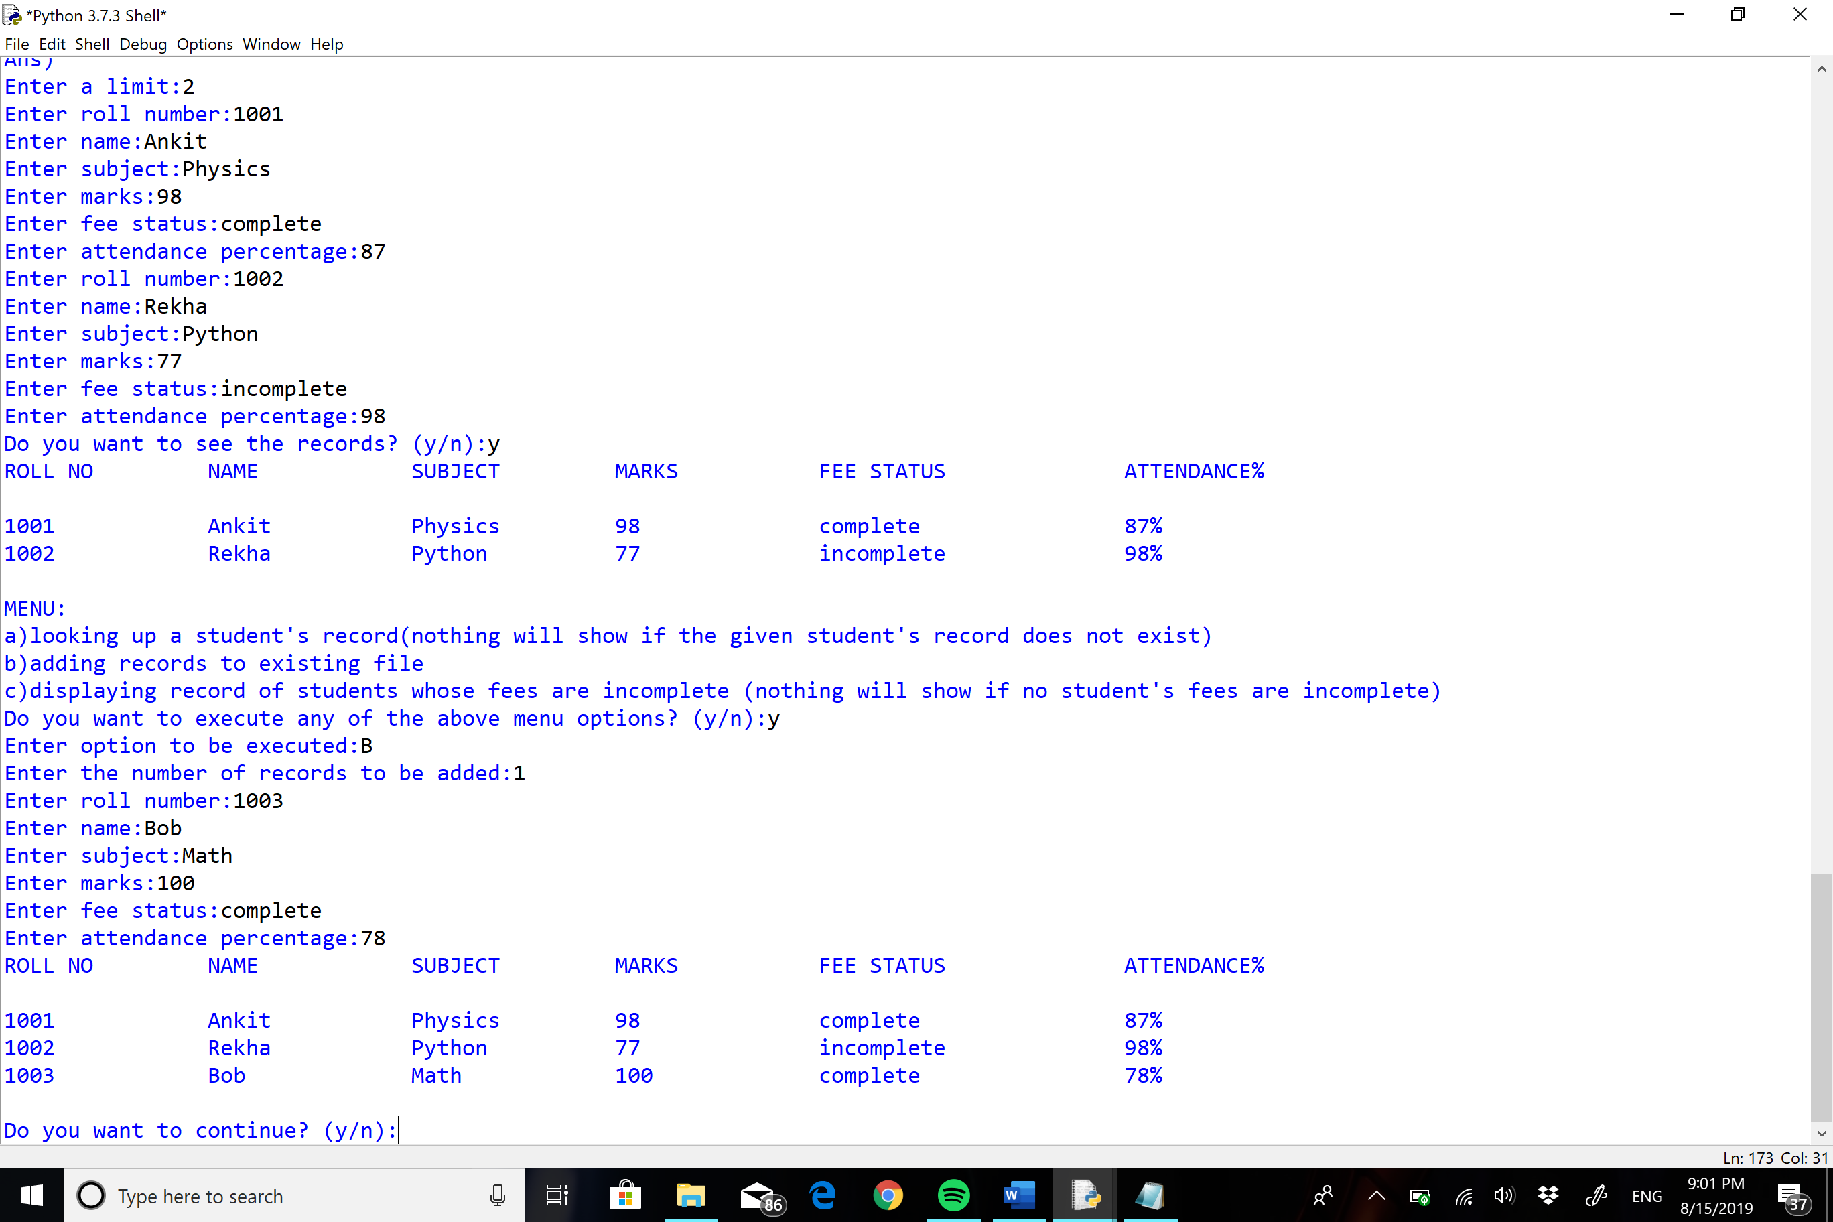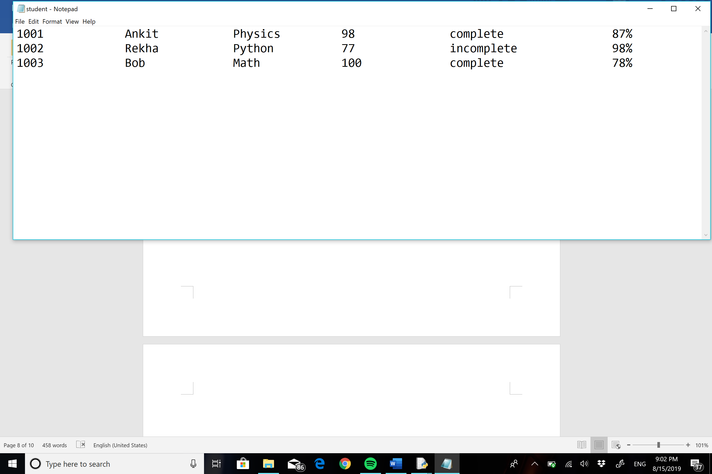

* Final output:

